**Schematic:**

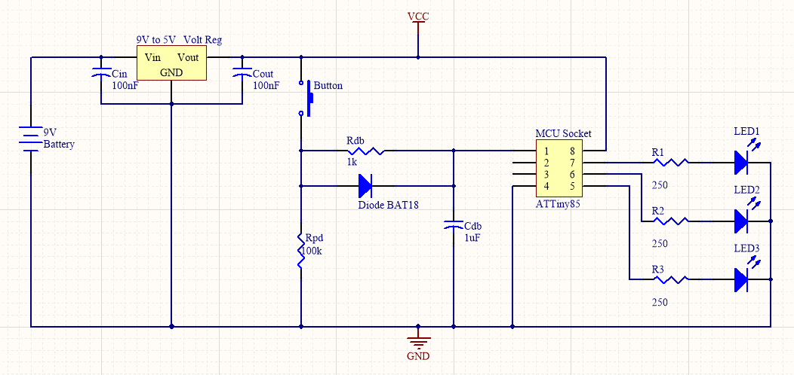

**Software Flowchart:**

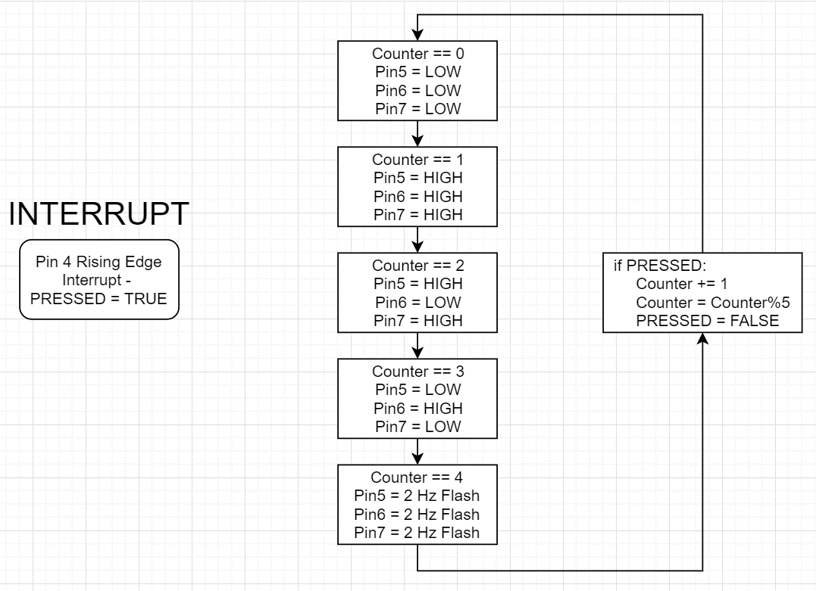

**Pseudo Code:**

Interrupt – Button state – rising edge on Pin 4 – PRESSED = TRUE

counter = 0

loop()

If PRESSED

counter += 1

counter = counter%5

PRESSED = FALSE

Switch case:

Case 1: counter == 0

Pin5 = LOW

Pin6 = LOW

Pin7 = LOW

Case 2: counter == 1

Pin5 = HIGH

Pin6 = HIGH

Pin7 = HIGH

Case 3: counter == 2

Pin5 = HIGH

Pin6 = LOW

Pin7 = HIGH

Case 4: counter == 3

Pin5 = LOW

Pin6 = HIGH

Pin7 = LOW

Case 5: counter == 4

Pin5 = 2 Hz Flashing (PWM)

Pin6 = 2 Hz Flashing (PWM)

Pin7 = 2 Hz Flashing (PWM)